Add fixed page after validation

Make sub questions expanded

Gabby will give example of question with 2 subs on both answers\

On validate – why plus minus showing up?

Add comment functionality

Check demo notes for add attachments of previously saved.

On Specialist search

Add drop down to Mech on Grant Number??

Change:

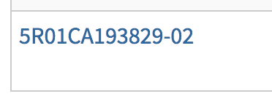

to end in 03A1 -- and change budget year to 2017

change CA to the same

on program page change Grant Number to first line and on same line as fiscal year and make Grant Number on left

Make Legend on one line

Capitalize the word deleted on Reset warning

Preview All Sub Questions / Exit Preview

Gray out entire form/ disable

On Submitted pages keep action buttons but disable and add tooltip saying it is read only mode